CS 305 Module Five Coding Assignment Checksum Verification Template

Instructions
Using the instructions from the Module Five Coding Assignment Checksum Verification Guidelines and Rubric, replace the bracketed text with the relevant information in your own words.

Algorithm Cipher

I recommend SHA-256 (Secure Hash Algorithm 256-bit) for the checksum verification. In Java, SHA-256 is a standard algorithm name that can be used with the MessageDigest class, and it produces a 256-bit message digest (Oracle, n.d.). This makes it a practical choice for creating a checksum that clients can use to verify that the downloaded public-key file has not changed during storage or transmission.

Justification

A cryptographic hash function converts input data into a fixed-length digest that acts like a fingerprint for the original data. A collision occurs when two different inputs produce the same hash value. Because a finite-length digest can never make collisions mathematically impossible, the security goal is to use an algorithm for which finding a collision is computationally impractical. NIST explains that secure hash algorithms support integrity checking because a change to a message will, with very high probability, create a different digest (National Institute of Standards and Technology [NIST], 2015). SHA-256 is appropriate for this assignment because it is widely supported in Java, generates a 256-bit digest, and is suitable for comparing a downloaded file against a trusted published checksum. If the client calculates a different SHA-256 value, the file should not be trusted until the difference is investigated.

Generate Checksum

You’ll submit your refactored code to your instructor. Your instructor will review it and this document.
I refactored ServerApplication.java so the /hash REST route uses the data string “Nathan Burlison.” The controller creates a MessageDigest object with MessageDigest.getInstance("SHA-256"), converts the data to UTF-8 bytes, calls digest() to create the hash, and passes the resulting byte array to a bytesToHex() method. The route then returns the original data, the SHA-256 algorithm name, and the hexadecimal checksum in the browser. Oracle lists SHA-256 as a standard MessageDigest algorithm in the Java Security API (Oracle, n.d.).

Verification

Insert a screenshot below of the web browser with your unique information.

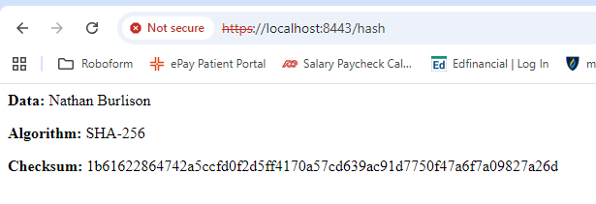

References
National Institute of Standards and Technology. (2015). Secure Hash Standard (SHS) (FIPS PUB 180-4). U.S. Department of Commerce. https://doi.org/10.6028/NIST.FIPS.180-4

Oracle. (n.d.). Java security standard algorithm names. https://docs.oracle.com/javase/9/docs/specs/security/standard-names.html

